Bradley Lowe
Chelsea Thompto
ART 2434
30 September 2026

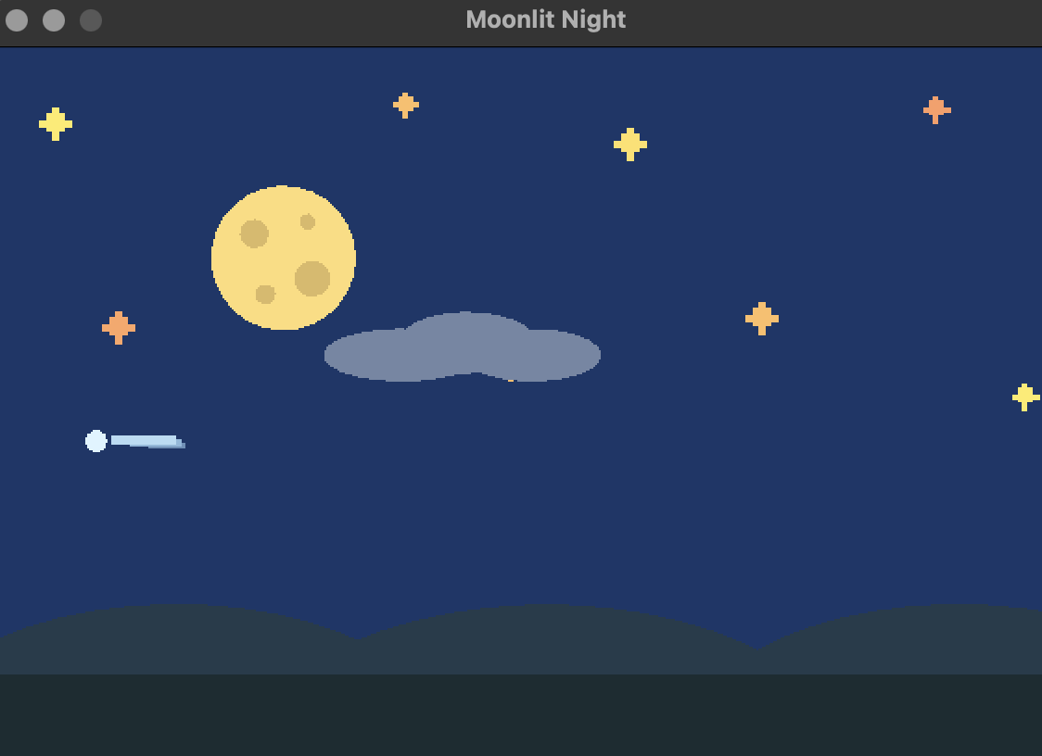

I started making the work visually interesting and unified by creating a nighttime landscape using simple shapes and colors. I used circles for the moon and its craters, rectangles and circles for the stars, ellipses for the clouds and hills, and a few simple shapes to create the comet. I kept the colors mostly dark blue, with yellow and lighter blue, so everything worked well together. For the animations, I had the stars twinkle at different speeds, with the moon slowly changing its size, and the cloud moving across the sky, along with the comet slowly passing through the background.

